New and Used Inc. Germantown, MD 20876
Tel: 301-540-2623
Fax:301-540-1870

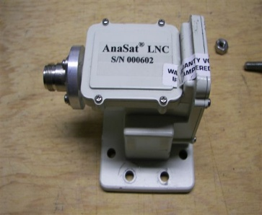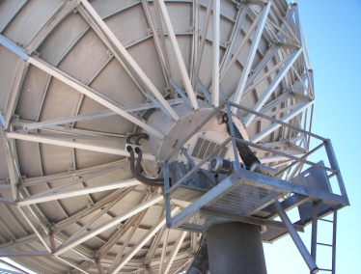
Notes: Used Andrew C-Band four port linear combiner. Fits Andrew Gregorian optics antennas including: 3.7m, 4.6m, 5.6m, 7.3m, 9.1m, 9.3m, 10m, 12m.

Equipment Type | C-Band 4 port combiner
Manufacturer | Andrew/ASC
Serial #
Model
Frequency In
  3.625-4.200
Frequency out | 5.850-6.425

Remarks / Comments

